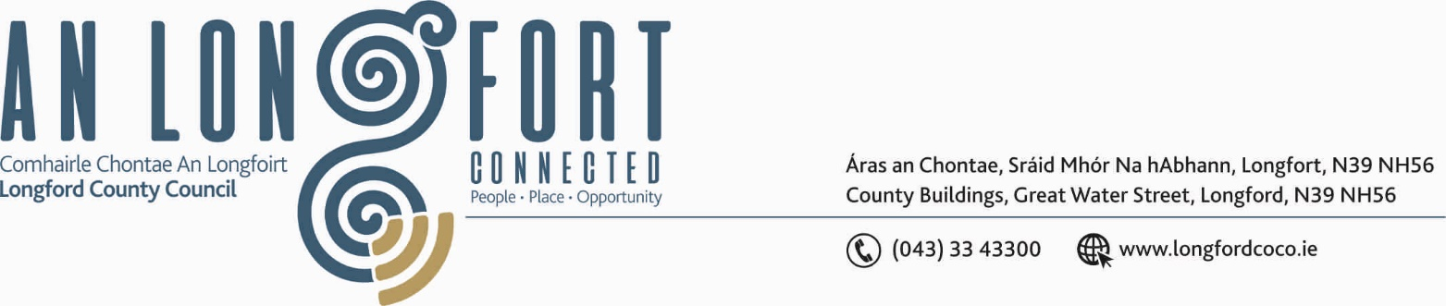

GRANARD MUNICIPAL DISTRICT

Please Note Venue of Meeting - Granard Community Library

15th October 2020.

To: Each Member of Granard Municipal District.

A Chomhairleoir,

You are requested to attend Granard Municipal District Meeting on Tuesday, 27th October 2020 at 4.00 p.m. in Granard Community Library to consider the 2021 General Municipal Allocation.

Mise le meas,
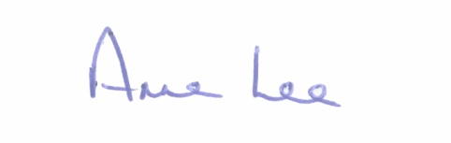

________________
Anne Lee,
Meetings Administrator.



